1. SANKALP’S SUPPLEMENTARY OR COMPLEMENTARY EDUCATION PROGRAMME

The flagship programme of SANKALP “supplementary/ complementary education programme” provides free education to children in economically backward rural areas. The programme primarily works with underprivileged and deserving students through after-school support centers which run in evening/morning. Mostly, the parents of these children are laborers, farmers, and domestic helps and are unable to support the educational needs of their children. The inability of parents to guide their children coupled with their illiteracy adds to the poor performance in their studies.

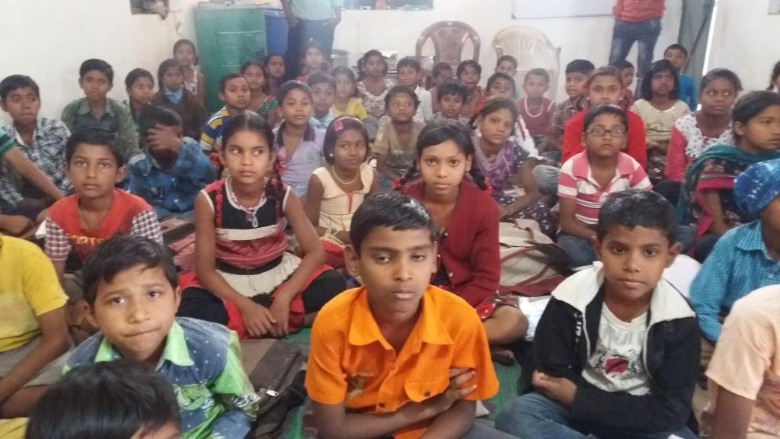
SANKALP provides 04 hours classes in Science, Math and English for marginalized children through our SANKALP Center in rural areas of Bhilai/Durg. In all these areas, the academic level of children is much below the national average and the children need remedial education. SANKALP has been able to enhance their academic level by approx 26% through Sankalp centers. SANKALP conducts monthly test in three subjects and monitor progress for all such children on regular basis.

NO OF BENEFICIARIES
SANKALP SUPPORT SCHOOL [ DATA AS ON 31.03.2017]
SN | CENTRE LOCATION | I | II | III | IV | V | VI | VII | VIII | IX | X | TOTAL
1 | NARDHI |  |  |  |  | 17 | 8 | 14 | 16 |  |  | 55
2 | AOUNDHI |  |  |  |  | 18 | 13 | 19 | 11 |  |  | 61
3 | BATANG |  |  |  |  | 19 | 17 | 17 | 14 |  |  | 67
4 | SOMNI |  |  |  |  | 10 | 8 | 8 | 14 |  |  | 40
5 | SANTOSHIPARA |  |  | 11 | 12 | 20 |  |  |  |  |  | 43
6 | MORID |  |  | 22 | 16 | 16 | 21 | 18 | 11 |  | 12 | 116
7 | NEWAI |  |  |  | 10 | 20 | 6 | 2 | 10 |  |  | 48
8 | GANIYARI |  |  |  |  | 18 | 22 | 22 | 25 |  |  | 87
9 | SIRSAKALA |  |  |  |  | 15 | 21 | 21 | 17 |  |  | 74
10 | UMARPOTI BHATHA |  |  |  | 10 | 12 | 9 | 10 | 4 | 4 |  | 49
11 | DUMARDIH |  |  |  | 9 | 10 | 15 | 2 | 1 |  |  | 37
12 | GAUTAM NAGAR | 4 | 5 | 7 | 5 | 3 | 1 |  |  |  |  | 25
13 | RAVELI | 10 | 14 | 12 | 17 | 8 | 15 | 12 | 9 |  |  | 97
14 | PACHPEDI | 8 | 2 | 4 | 21 | 11 | 13 | 4 | 3 |  |  | 66
15 | MARODA |  |  |  | 14 | 3 | 13 | 7 | 2 |  |  | 39
16 | TARRA | 21 | 11 | 15 | 19 | 26 |  |  |  |  |  | 92
17 | DUNDERA | 16 | 18 | 36 | 32 | 30 |  |  |  |  |  | 132
18 | SAHEED VEEN NARAYAN NAGAR | 6 | 5 | 4 | 5 | 6 |  |  |  |  |  | 26
19 | SONIYA GANDHI NAGAR | 10 | 12 | 10 | 10 | 11 | 10 | 8 | 8 | 4 | 5 | 88
 | TOTAL | 75 | 67 | 121 | 180 | 273 | 192 | 164 | 145 | 8 | 17 | 1242

2. PROJECT- UDDAN
SANKALP commenced its computer training programme “UDDAN” which has covered 490 children till date. This project covers Certified Computer Training Module. The children from Class IV to IX are covered in the programme. The main objective of the project is to provide basic computer training to the underprivileged with focus on computer literacy required at their age.
COMPUTER TEACHING PROGRAMME [UPTO 15-16]

SN | Duration | Centre | No. of  beneficiaries
1 | 01.04.2014 to 31.07.2014 | Morid | 70
2 | 01.04.2014 to 31.07.2014 | Nardhi | 90
3 | 01.04.2014 to 31.07.2014 | Newai | 70
4 | 01.04.2014 to 31.07.2014 | Umar Poti | 70
 | 300
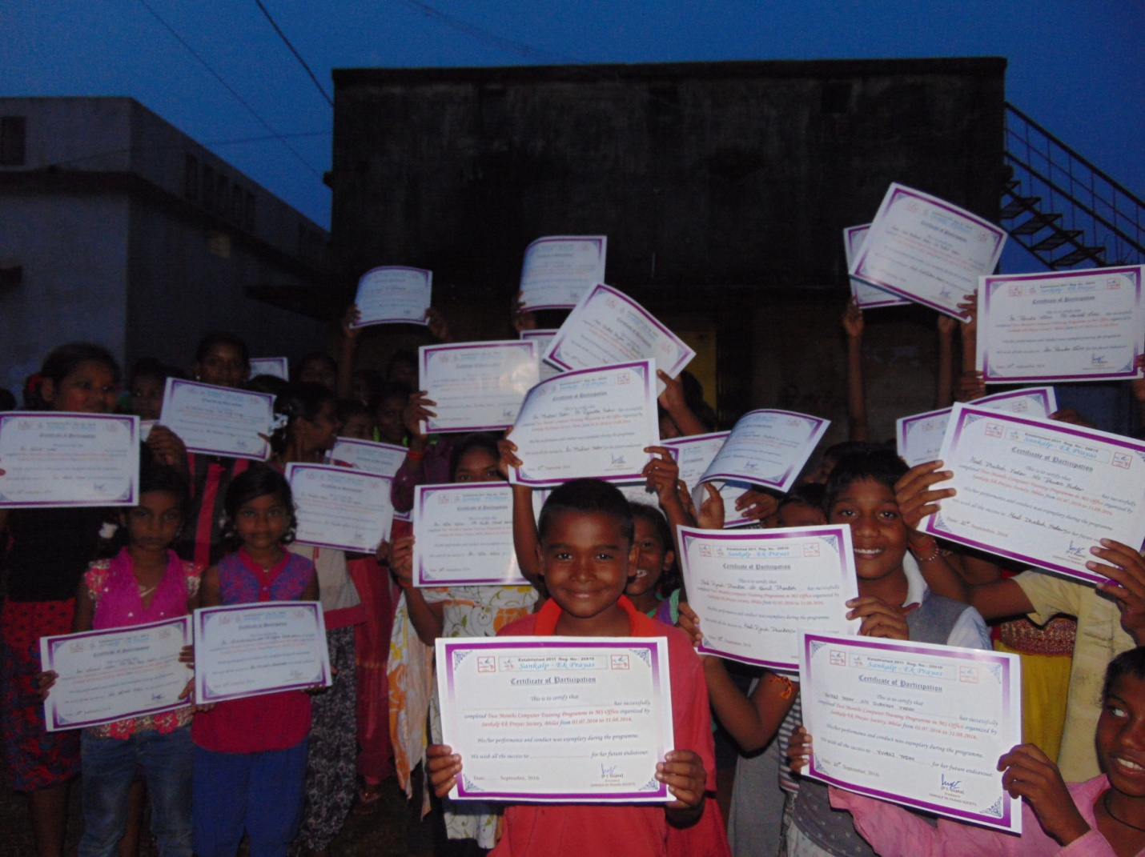
COMPUTER TEACHING PROGRAMME [IN 16-17]
SN | Duration | Centre | No. of  beneficiaries
1 | 20.09.2016 to 20.12.2016 | Ruabandha Government Primary School | 70
2 | 01.07.2016 to 31.08.2016 | Village- Newai | 60
3 | 01.07.2016 to 31.08.2016 | Village- Maroda | 60
 |  |  | 190

TOTAL BENEFICIARIES [ PROJECT UDDAN]
IN 16-17 | UPTO 16-17 (CUMULATIVE)
190 | 490

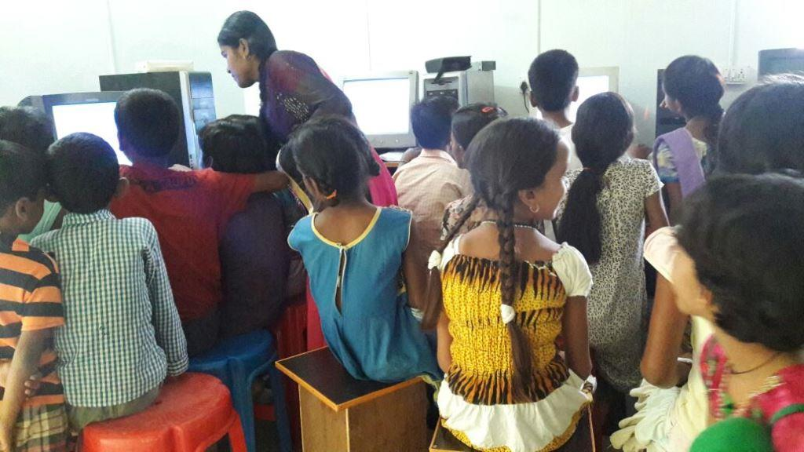

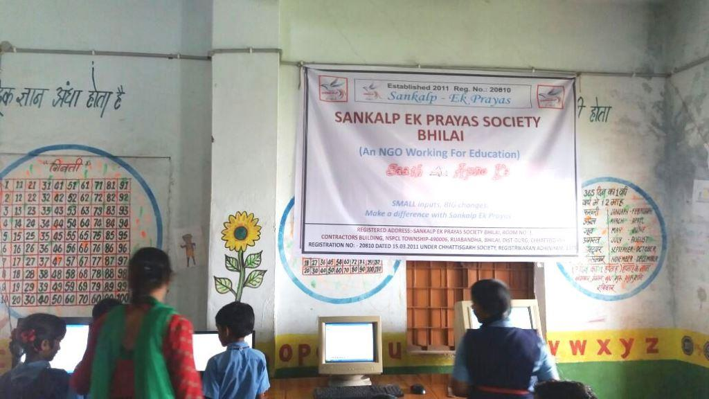
3. PROJECT- SAKSHAM

Sankalp conducts “SAKSHAM” project through which the NGO administers Training Program for rural women. The graduates/undergraduates from rural villages are trained in Basic English, Mathematics and Science through this course. For each subject, Pre Tests and Post Tests are conducted with different set of test papers with same level of scientifically confirmed equivalency. The scores by the participants reflect significant change in their level.

PROJECT- SAKSHAM[UPTO 15-16]
SN | DURATION | LOCATION | NO OF BENEFICIARIES
1 | 19.06.2015 to 20.08.2015 | Morid | 75

PROJECT- SAKSHAM [2016-17]
SN | DURATION | LOCATION | NO OF BENEFICIARIES
1 | 22.02.2017 to 27.02.2017 | Morid, Narthi, Batang, Dundera, Umerkoti, Newai, Maroda, Dumerdih | 20
OUTCOME OF THE TEACHER TRAINING COURSE
DETAILS | MATH | ENGLISH | SCIENCE
PRE TEST SCORE(Av) | 37.2 | 36.38 | 53.68
POST TEST SCORE (Av) | 68.4 | 52.23 | 72.72
% DIFFERENCE | 31.2 | 15.85 | 19.04

TOTAL BENEFICIARIES [ PROJECT SAKSHAM]
IN 16-17 | UPTO 16-17 (CUMULATIVE)
20 | 95

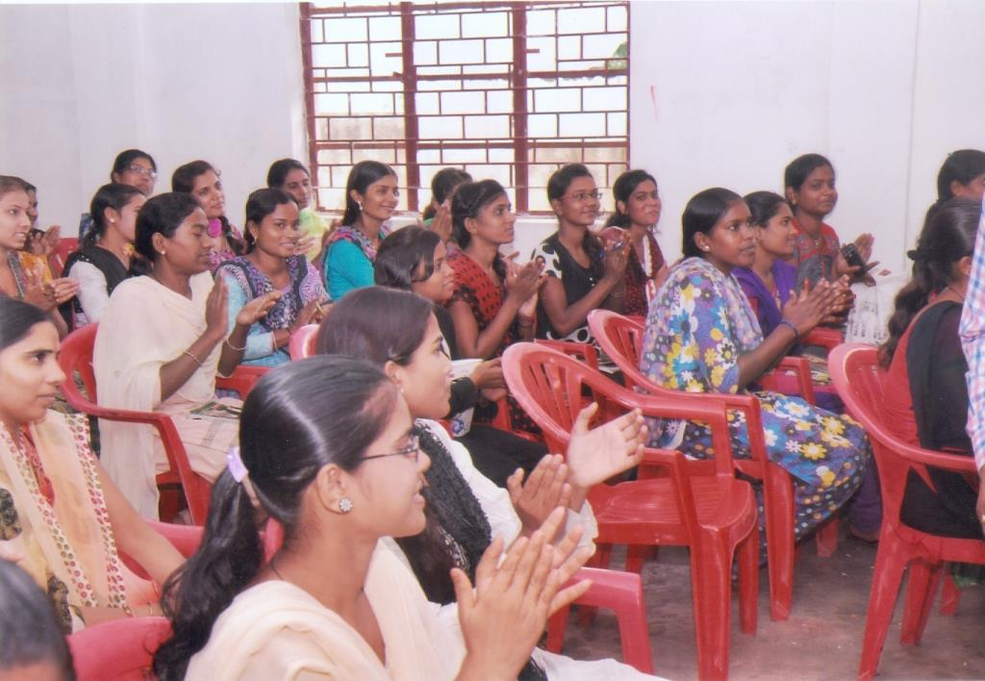

4. PROJECT- e MERGE

Through this programme, SANKALP EK PRAYAS aims at integrating e-learning techniques for ensuring improvement in academic standard of children. During this programme, the children are shown many online resources and tested through pre test and post test evaluation. The randomly selected children before the intervention and after the intervention have reflected significant change in their responses in the areas/syllabus covered in the intervention. The result of test has substantiated the significance of this intervention and SANKALP volunteers are working on developing the curriculum to ensure a quantifiable change through this project.

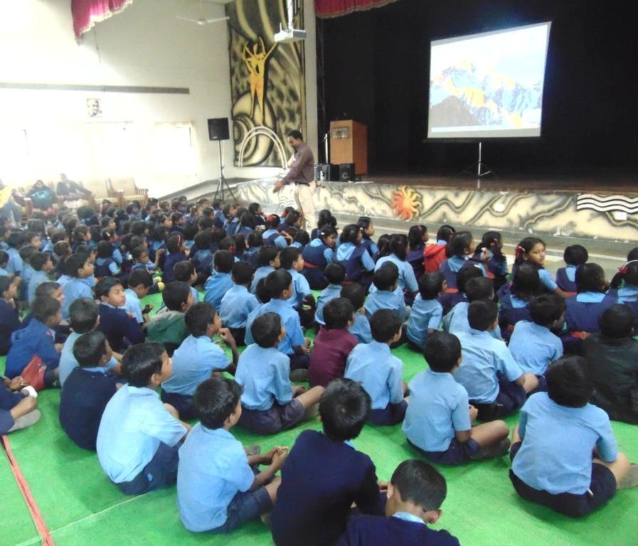

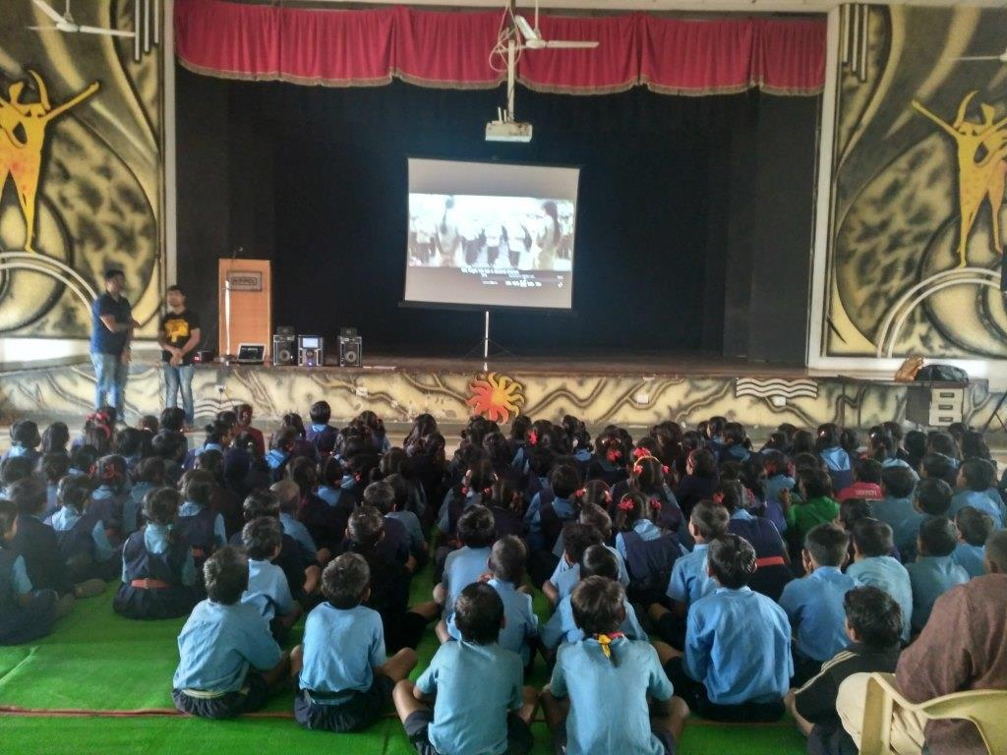

SN | Date | Centre | No. of  beneficiaries
1 | 30.12.2016 | Ruabandha | 194 Children of Class I to V
2 | 01.02.2017 to 15.02.2017 | Pragati Nagar Basti | 50 Nos of Street/Drug Addict Children

TOTAL BENEFICIARIES [ PROJECT e MERGE]
IN 16-17 | UPTO 16-17 (CUMULATIVE)
244 | 244

5. SUPPORT SCHOOL

Through its “Support School” project, Sankalp hires full time teachers and engage them in the rural government schools, where teachers are not available, for ensuring better result and future of the children. SANKALP incurs the expenses of hiring and engaging teachers in the school. The performance and progress of children are monitored by SANKALP team during the entire period of engagement of such teachers. With this intervention, SANKALP has demonstrated significant improvements in annual result of Board examination for the schools wherein such intervention has been undertaken.

PROJECT- SUPPORT SCHOOL[UPTO 15-16]
SN | Details | LOCATION | NO OF BENEFICIARIES
1 | Sponsoring 2 Full Time Teachers at Morid High School | Morid High School | 70

Project Sponsoring Full Time Teacher at Government School [FY 16-17]

SN | Details | Place | No. of  beneficiaries
1 | Sponsoring 2 Full Time Teachers at Morid High School from July-2016 to March-2017 | Morid High School | Approx 80 Children of Class IX and X

TOTAL BENEFICIARIES [ SPONSORING FULL TIME SCHOOL TEACHER]
IN 16-17 | UPTO 16-17 (CUMULATIVE)
80 | 150

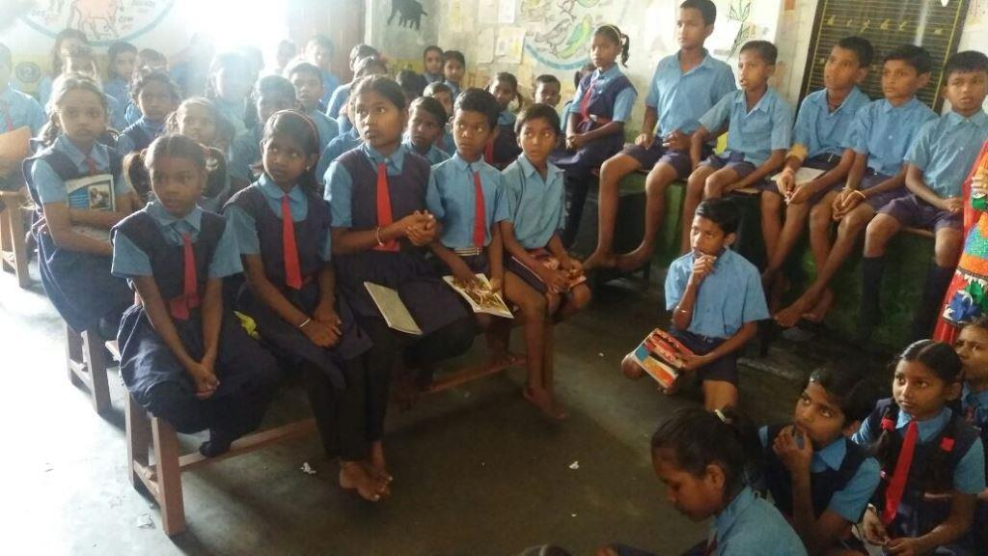

6. PROJECT- SAVE A CHILDHOOD

SANKALP’s “SAVE A CHILDHOOD” project aims at arranging shoes, socks, uniforms etc for needy children in the rural villages. Through the “SAVE A CHILHOOD CAMPAIGN”, Sankalp tries to ensure that the children who walk barefoot/ children who do not have uniform on account of economic reason could be supported. Many supporters from many part of the nation have joined this campaign to help needy children and Sankalp serves the children with the recourses arranged by its volunteers.
SAVE A CHILDHOOD PROGRAMME
SL | Date | Place | No of Beneficiaries | Remarks
1 | 25.11.2016 | Ruabandha Government Primary School | 200 | Shoes distribution
2 | 23.12.2016 | Village- Raveli | 83 | Shoes distribution
3 | 23.12.2016 | Village- Aundhi | 53 | Shoes distribution
4 | 23.12.2016 | Village- Batang | 68 | Shoes distribution
5 | 23.12.2016 | Village- Narthi | 68 | Shoes distribution
6 | 12.01.2017 | Village- Tarra | 93 | Shoes distribution
7 | 31.01.2017 | Village- Pachpedi | 65 | Shoes distribution
8 | 31.01.2017 | Village- Sirsakala | 77 | Shoes distribution
9 | 31.01.2017 | Village- Morid | 95 | Shoes distribution
10 | 31.01.2017 | Village- Gughsidih | 77 | Shoes distribution
11 | 03.01.2017 | Village - Newai and Umerpoti | 57 | Shoes distribution
 |  |  | 936

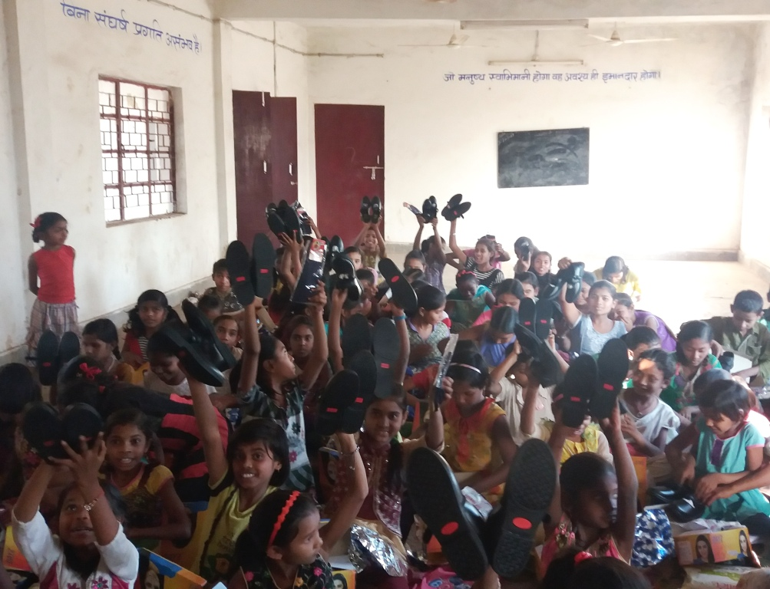

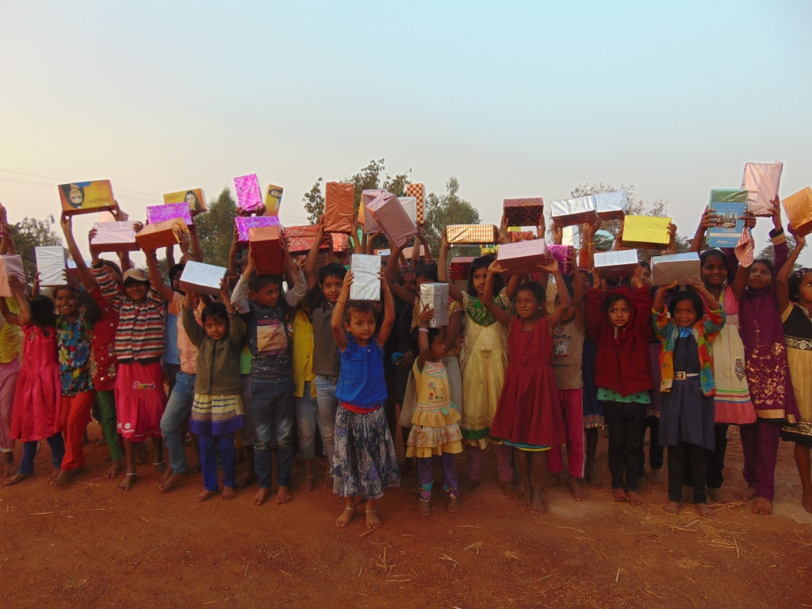

7. PROJECT- SCHOOL TO SCHOOL

SANKALP is partnering “SCHOOL to SCHOOL” programme with GOONJ (a nationally recognized NGO). The programme aims at motivating SANKALP children to be socially responsible and be properly educated. Through this programme l children are involved in engaging sessions to get them sensitized with various virtues and skills. These children are provided with school kits and gifts in appreciation of their ongoing academic progress and learning.

Under SCHOOL to SCHOOL programme, GOONJ and SANKALP reach various SANKALP centers and conduct engaging sessions for kid minds. The programme aims at sensitizing children towards various causes and lets them realize their own privileged status. This programme helps them developing into not only responsible individuals but also as significant change makers who will contribute positively to society.

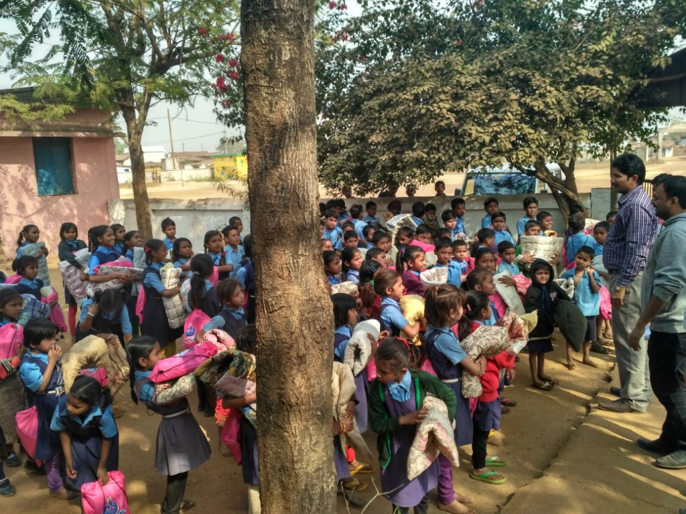

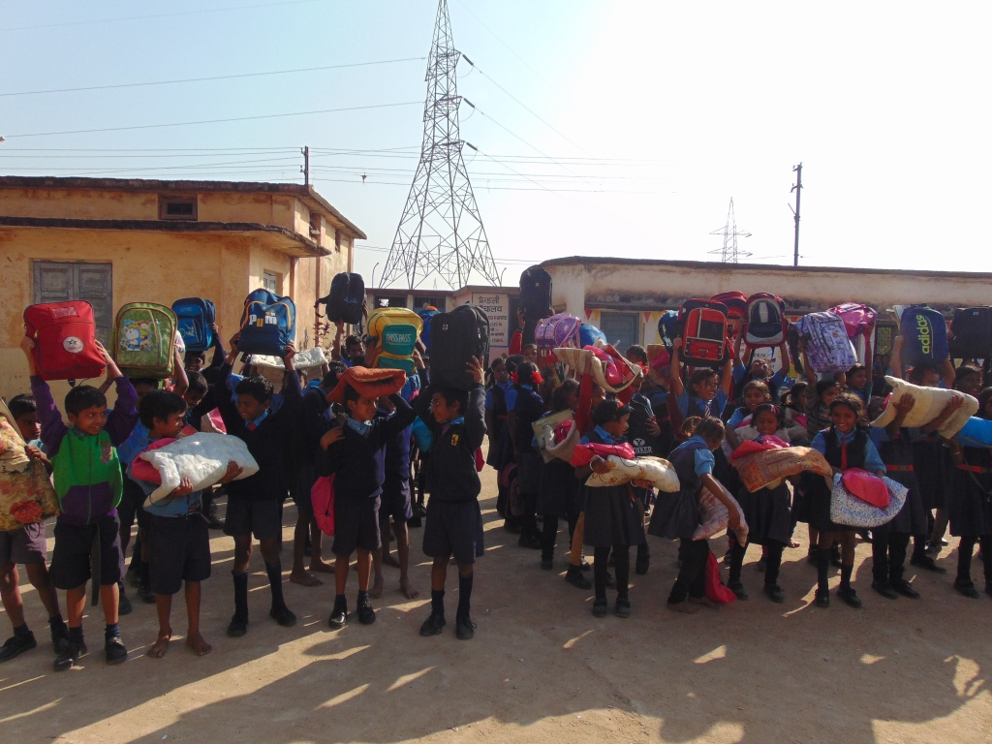

SCHOOL TO SCHOOL PROGRAMME DETAILS
SN | School | Date | Representative of Goonj Present | I | II | III | IV | V | Sub Total
1 | Narthi Primary School | 23.12.2016 | Yes | 25 | 35 | 37 | 27 | 26 | 150
2 | Somni Primary School | 31.12.2016 | Yes | 20 | 16 | 20 | 15 | 34 | 105
3 | Morid Primary School | 31.12.2016 | Yes | 34 | 32 | 23 | 39 | 41 | 169
4 | Ruabandha Primary School | 06..01.2017 | No |  |  | 11 | 42 | 27 | 80
Grand Total |  |  |  | 79 | 83 | 91 | 123 | 128 | 504
TOTAL BENEFICIARIES [ PROJECT SCHOOL TO SCHOOL]
IN 16-17 | UPTO 16-17 (CUMULATIVE)
504 | 504

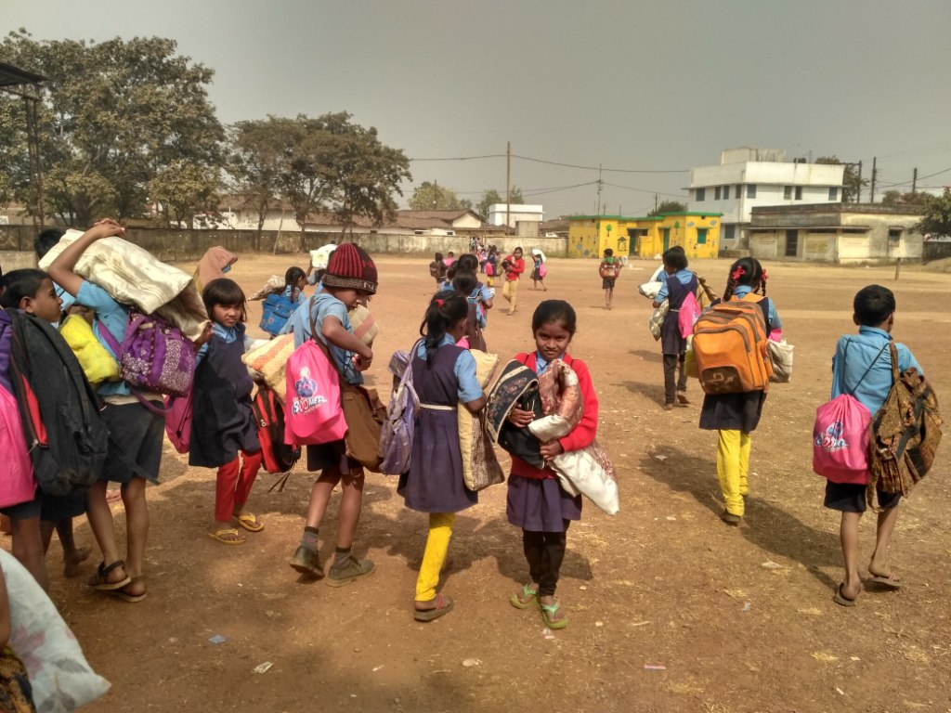

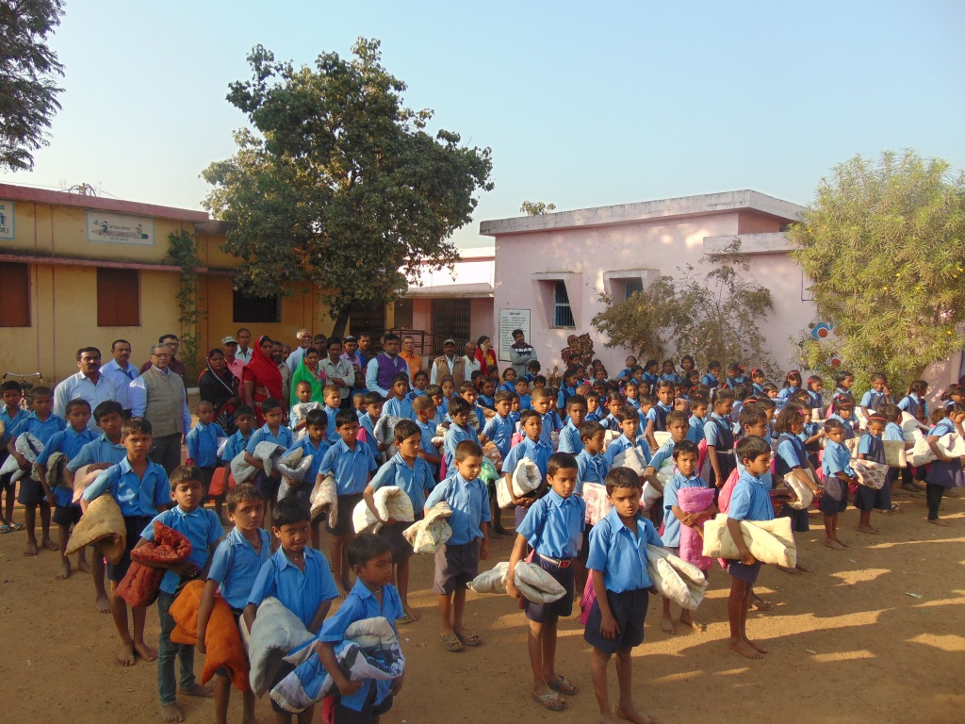

8. PROJECT- CONNECTION DOTS

SANKALP facilitates all-round development of children through its “Connecting Dots” project and conducts personality development workshops in these villages focusing on all-round development of children. Through these workshops, SANKALP is also helping children in developing their interest and skills in extracurricular activities. The children are trained in drawing, painting, sketching, collage making, quelling art, model building, greeting card making and other art through these workshops.

(a) Project- Connecting Dots- Drawing/Painting Workshop

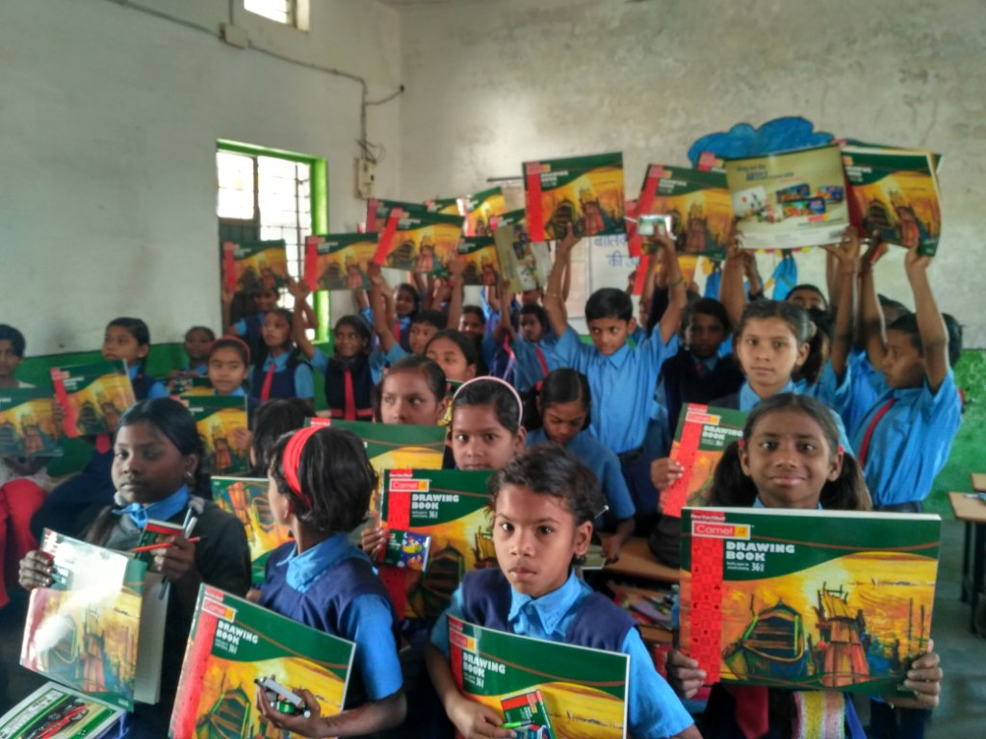

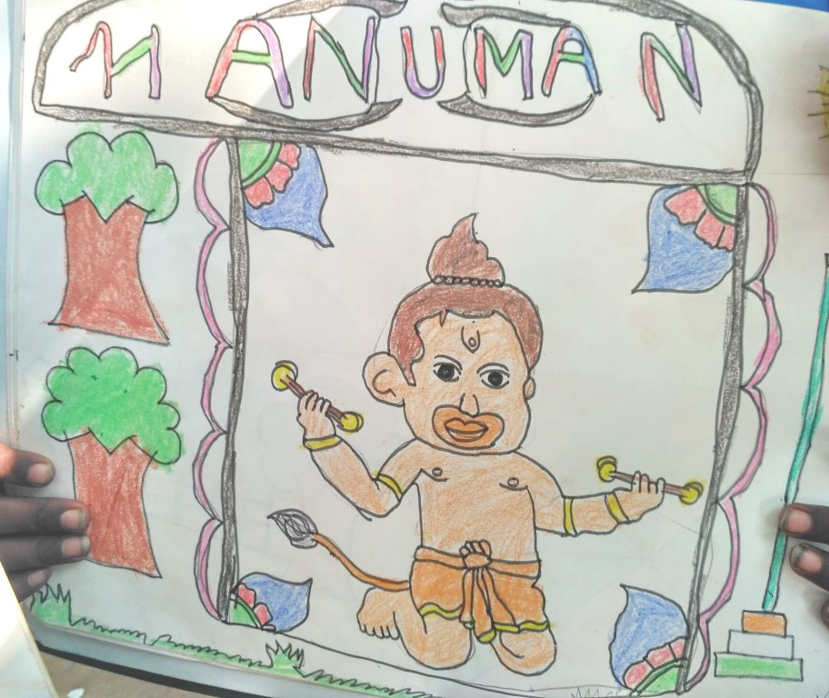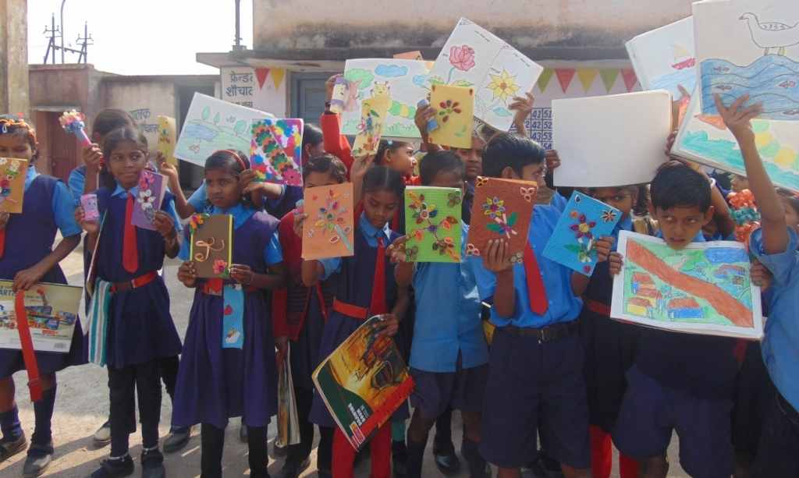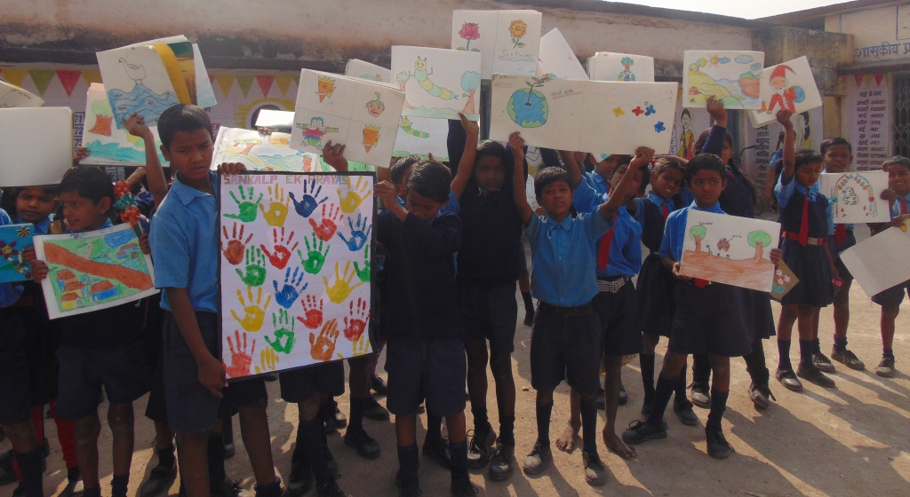

- Stationery Distribution- 02.10.2016 [200 Nos] at Ruabandha Government School
- Workshop from 01.11.2016 to 25th Nov 2016
- Drawing Sheet Distribution- 17 .11.2016 (35 Nos) and 21.11.2016 (40 Nos)
- Exhibition of Children- 09.12.2016

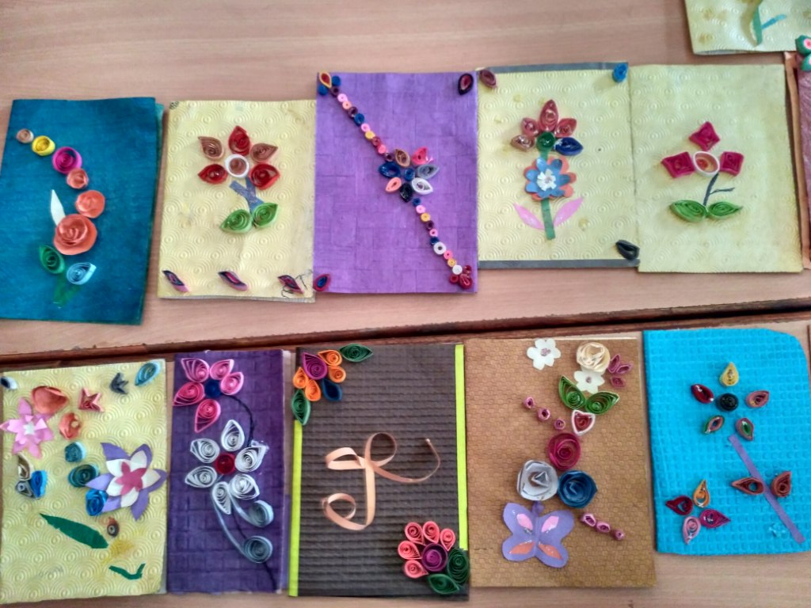
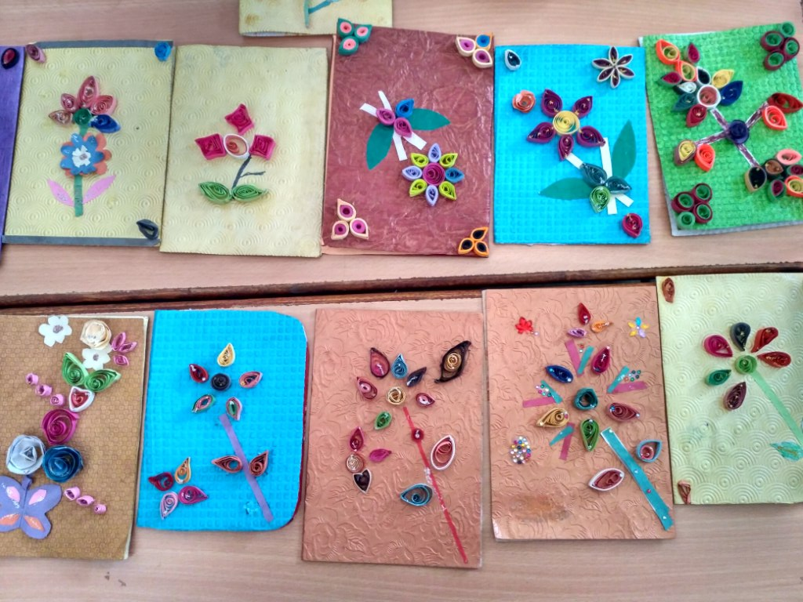

(b) Connecting Dots-Motivational and Personality Development Workshop by IIM Students

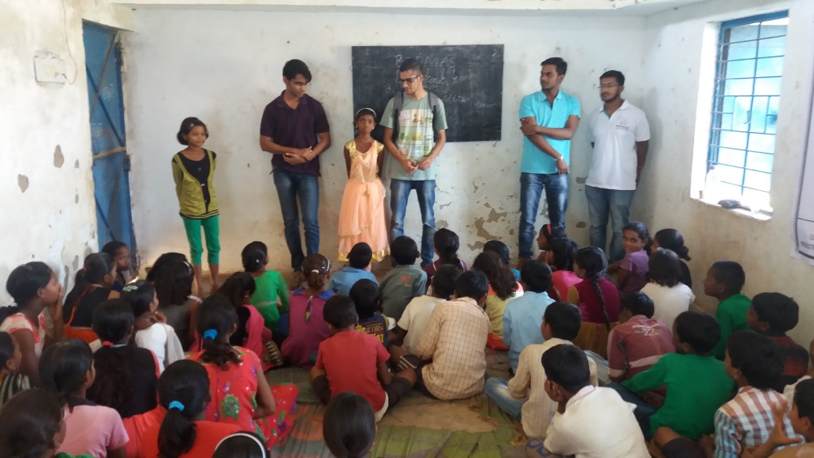
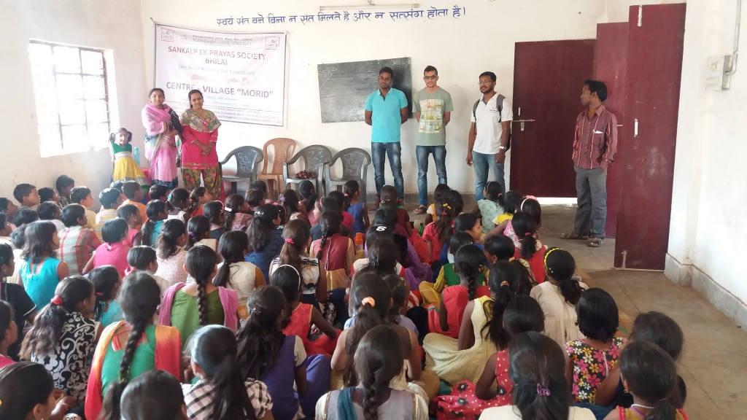

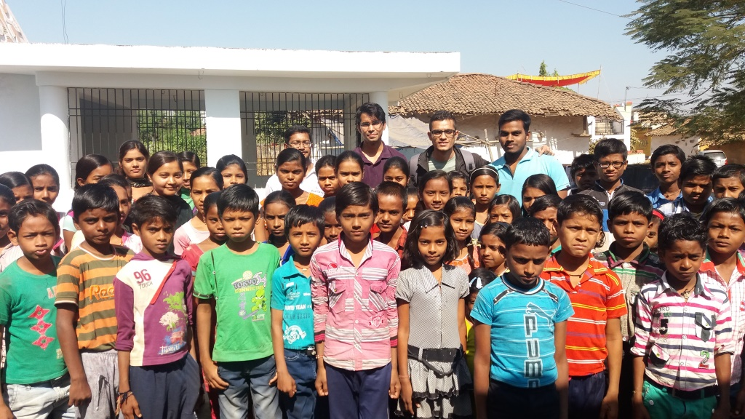

SN | Details | Place | No. of  beneficiaries
1 | The management students from Indian Institute of Management, Raipur conducted motivational and counseling classes on 27th November-2016 | Village- Aundhi, Batang, Narthi, Morid, Sirsakala, Ganiyari | Approx 500 Children of Class IX and X

( c)Project- Connecting Dots- Motivational and Personality Development Workshop

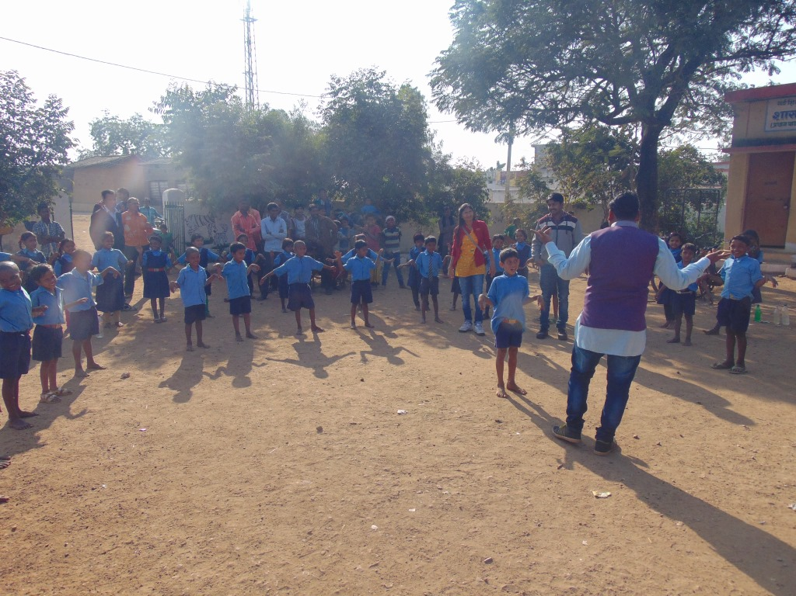

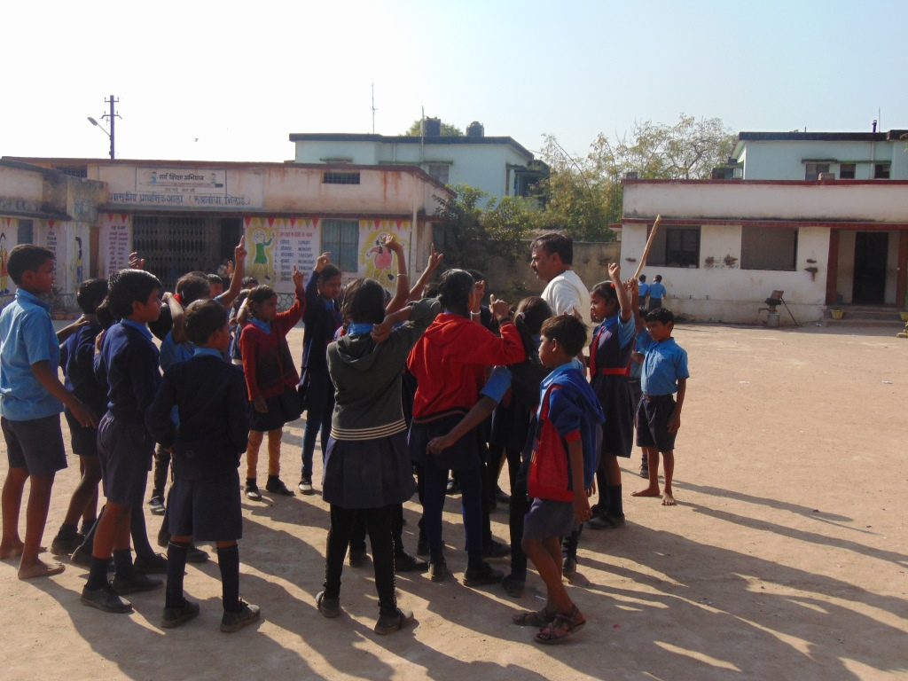

SN | School | Date | No of Beneficiaries
2 | Somni Primary School | 28.12.2016 to 31.12.2016 | 105
3 | Morid Primary School | 28.12.2016 to 31.12.2016 | 169
Grand Total- 274

(d) Project- Connecting Dots- Dancing Workshop

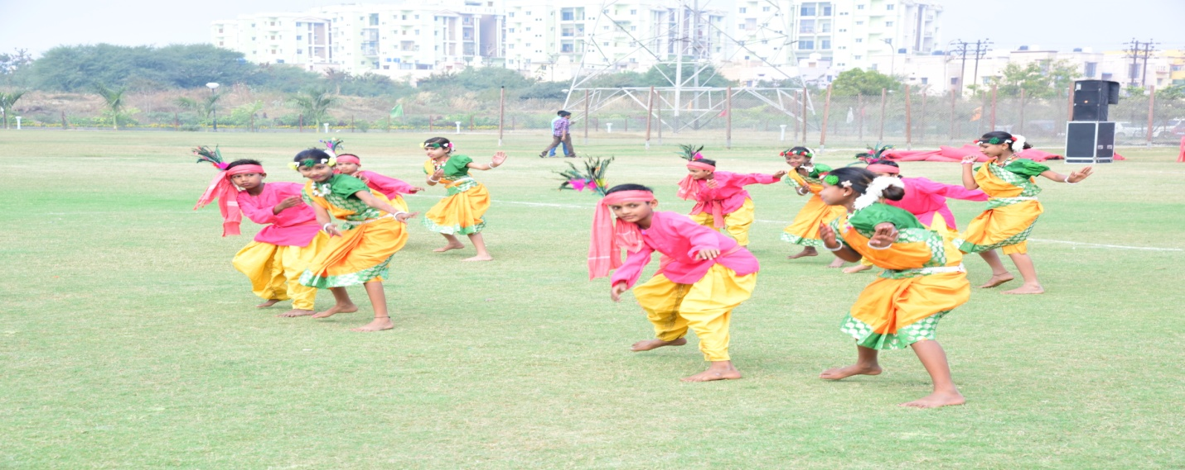
SN | Village | Date | No of Beneficiaries
1 | Ruabandha | 02.01.2017 to 25.01.2017 | 25
Grand Total- 25

(e) Project- Connecting - Child Psychology and Pedagogy Training at SANKALP Centers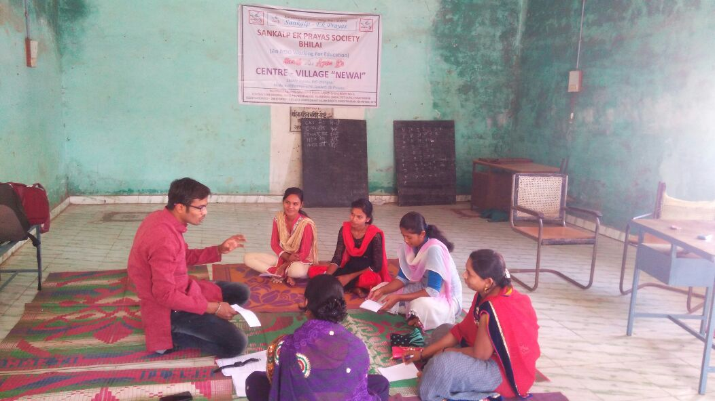

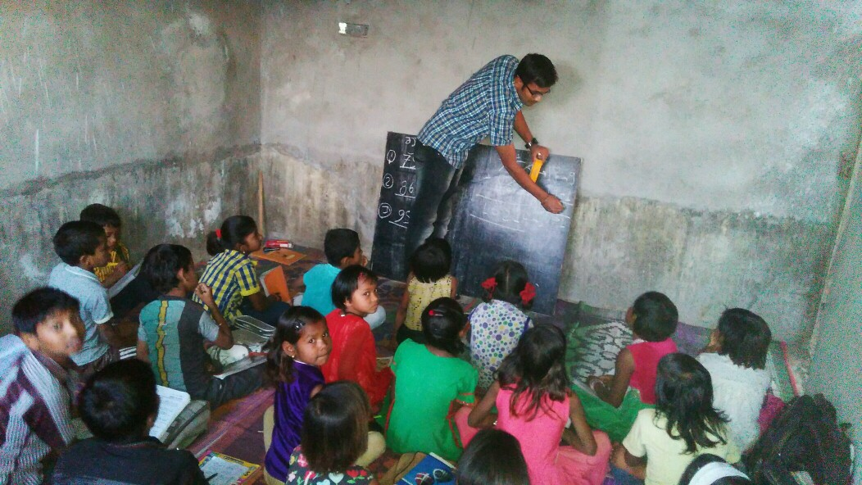

SN | Center | Date | No of Beneficiaries
1 | Morid, Narthi, Batang, Dundera, Umerkoti, Newai, Maroda, Dumerdih | 22.02.2017 to 27.02.2017 | 600 Children and 20 Teachers
Grand Total- 620

TOTAL BENEFICIARIES [ PROJECT CONNECTING DOTS]
IN 16-17 | UPTO 16-17 (CUMULATIVE)
1000 | 1000

9. PROJECT- BANDHAN

BANDHAN is a unique initiative at for promoting bonding among children. Teams with equal representation and comprising of girl child of privileged and underprivileged stratum display their sporting skills. The initiative aims at instilling strong value system among children.

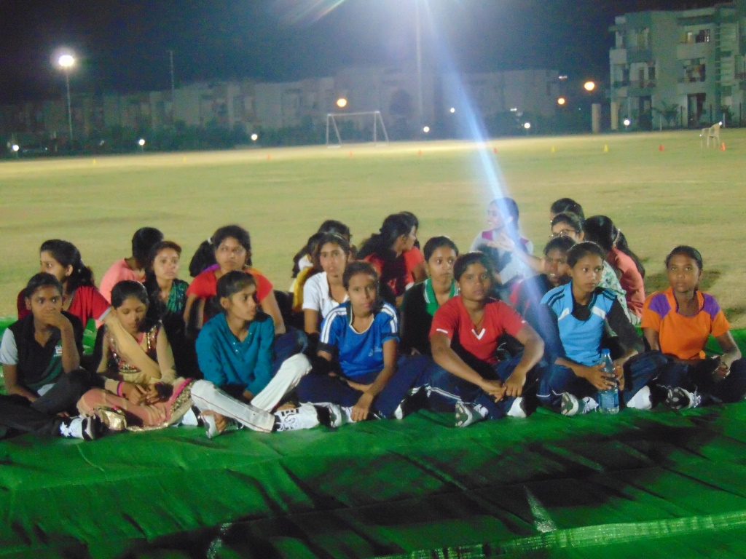
SN | Details | Date | No of Beneficiaries
1 | BANDHAN | 06.05.2016 | 20

